Second Grade’s STEM Challenge
“Build an Amusement Park Ride”

Problem: You are an engineer and you have been given the task to design a ride for a new amusement park coming to your town. In order to show you design you have been asked to build a 3-D model using recyclable materials. Your ride must have at least one movable component.

Tips: Along with your 3-D model, you must show in pictures and words how you used each step of the engineering design process when making your amusement park ride model. You could make a poster, a book, a PowerPoint or even video to show how you used the engineering design process. The graphic on the back shows all 5 parts of the engineering design process.

Project Specifications:
• Made from recyclable materials
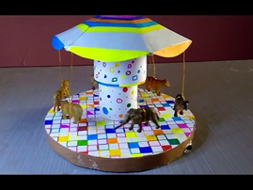
• Model must have at least one movable component
• Must be durable
• Must be neat

Projects are due on April 11th by 9:00 a.m. and judging will take place at STEM Family Night. Grade level winners will receive their own Makey Makey Invention Kit.
Fourth Grade’s STEM Challenge
“Build a Bridge”

Problem: There is a new road being built in your town, but it is going to cross over a large body of water. You have been asked to design a bridge that will be sturdy enough for cars, trucks, and people to cross. In order to show your design, you must build a smaller model out of only popsicle sticks and hot glue.
**Bridges will be judged on the use of materials, ability to hold the most weight, and innovation. The bridge that holds the most weight without breaking will be the winner!**
Tips: Along with your popsicle stick bridge, you must show in pictures and words how you used each step of the engineering design process when making your bridge. You could make a poster, a book, a PowerPoint or even video to show how you used the engineering design process. The attached graphic shows all 5 parts of the engineering design process.
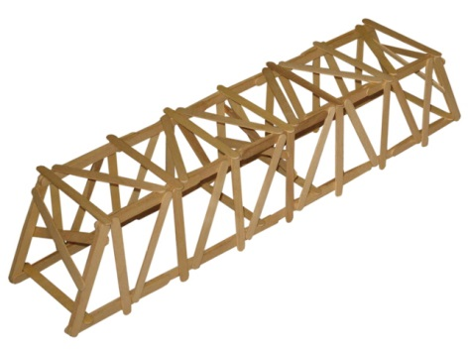
Bridge Specifications:
- Limit of 200 popsicle
sticks
- Only hot glue may be used
(limit 2 sticks)
- Bridge span must be
at least 14 inches wide

Projects are due on April 11th by 9:00 a.m. and judging will take place at STEM Family Night. Grade level winners will receive their own Makey Makey Invention Kit.

